The Glove Box Cooler

You will need to acquire a desk cable relief from Bunnings or Dick Smith ( about $8 to $13 ) depending on where you go. Dick Smith call them Desk Grommets. ( go to their website and search for a H1730. They are the plastic round things you see going through computer desks etc for your cables to go through. They have a centre swivel that you can either leave in to restrict the air flow of your vent or if you are like me I just took the whole thing out.
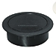

- Take the cable relief and scallop out about half of the plastic so that you end up with something like fig 1. ( I used a sharp pocket knife to do this )
- 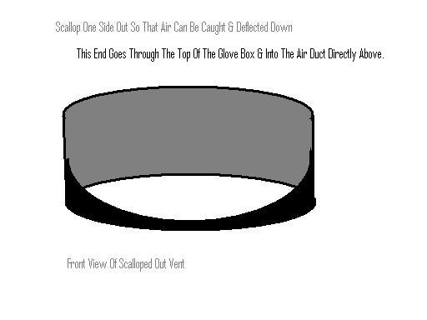
- Remove the glove box from the vehicle. ( all the screws in are behind the glove box door.
- With the aid of additional light look above the where the glove box was and you will see a flat looking black duct running from the heater unit ( centre dash ) to the right hand side in dash air vent.
- Now remove the passenger air vent grill from the dash so that you can see where the glove box was & the air duct.
- Now put the glove box back in holding it in place.
- Using extra light look through the air vent hole and you will see where the air duct sits directly above the glove box.
- Still holding the glove box in place use a pencil or a scriber and mark the top of the glove box & air duct where they intersect. This will be the outer limit of the hole you will make.
- Remove the glove box again and check that you can see where you have marked. If you are not sure repeat step 6 again. It is better to measure twice and cut only once.
- Now find a hole saw that will cut a whole the same size as the cable relief (grommet). Make sure it is a snug fit otherwise it will fall out.
- Make sure you are happy with your measurements and then proceed to drill the hole making sure the outer part of the whole does not exceed where you marked on the glove box.
- Now take a deep breath it will be ok.
- Put the glove box back in to where it is meant to go and while holding it in place and using the hole you just made as a guide mark out the circle on the air duct. Don’t worry if you are a little off. The cable relief will fix any minor mistakes in measuring.
- Depending on the drill you have you can either drill the hole in to the duct with it in the car or you can remove it by undoing the two screws that hold it in place. (I took it out)
- Now that the holes are drilled it is time to put it all back together. First the air duct if you took it out and then the glove box. Tighten the screws back up other wise it will fall out.
- Take the cable relief that you have shaped and with the scalloped out bit facing the centre vents, insert it through the holes. If it is tight great. If not use some electrical tape to take up the slack.
- Now turn on the vent and the fan to see what the air flow is like. You may have to twist the relief around a bit if you are not getting much air through. If you still don’t get much air, remove the relief and make the back of it higher with some packing tape and a bit of ice cream container or something similar to form a bigger deflector. Although I doubt whether this will be necessary.
- You are done. Throw the maps and crap into the back seat pockets and fill the glove box with 8 cans. I have found they cool best when laying down.
- The next step which I am yet to do but will soon is to wrap the back of the glove box in builders sisleation. ( blue alfoil stuff you see on new houses when they are being built) to insulate the box and help it stay cooler for longer when the car is not running.
- Have fun.
- Drawing below.

